NAVAIR - Data Acquisition Device

Final Project Binder

Team 42

April 28th, 2023

**Team Members:** Alex Miller, Max Engel, Timothy Ciavolella, Will Katz, Zach Krough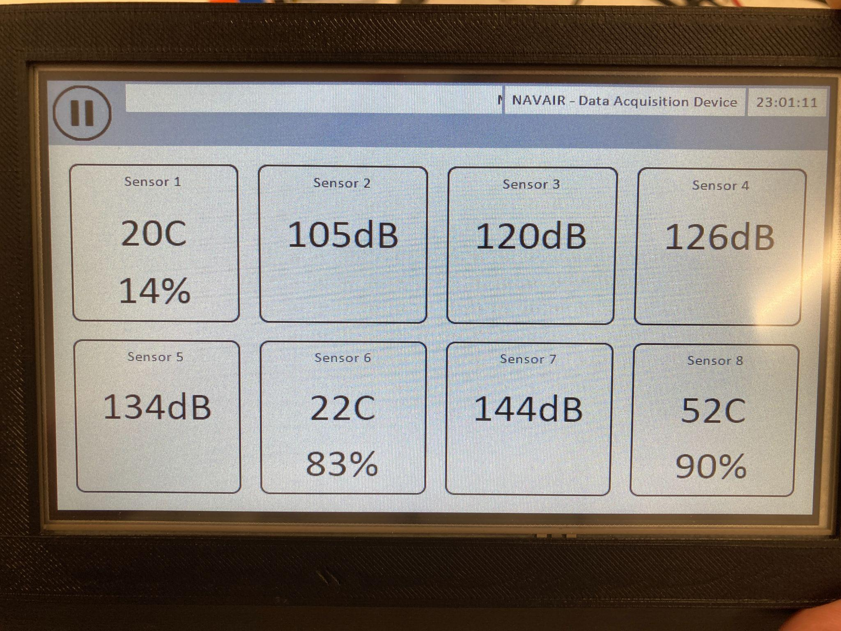

# 

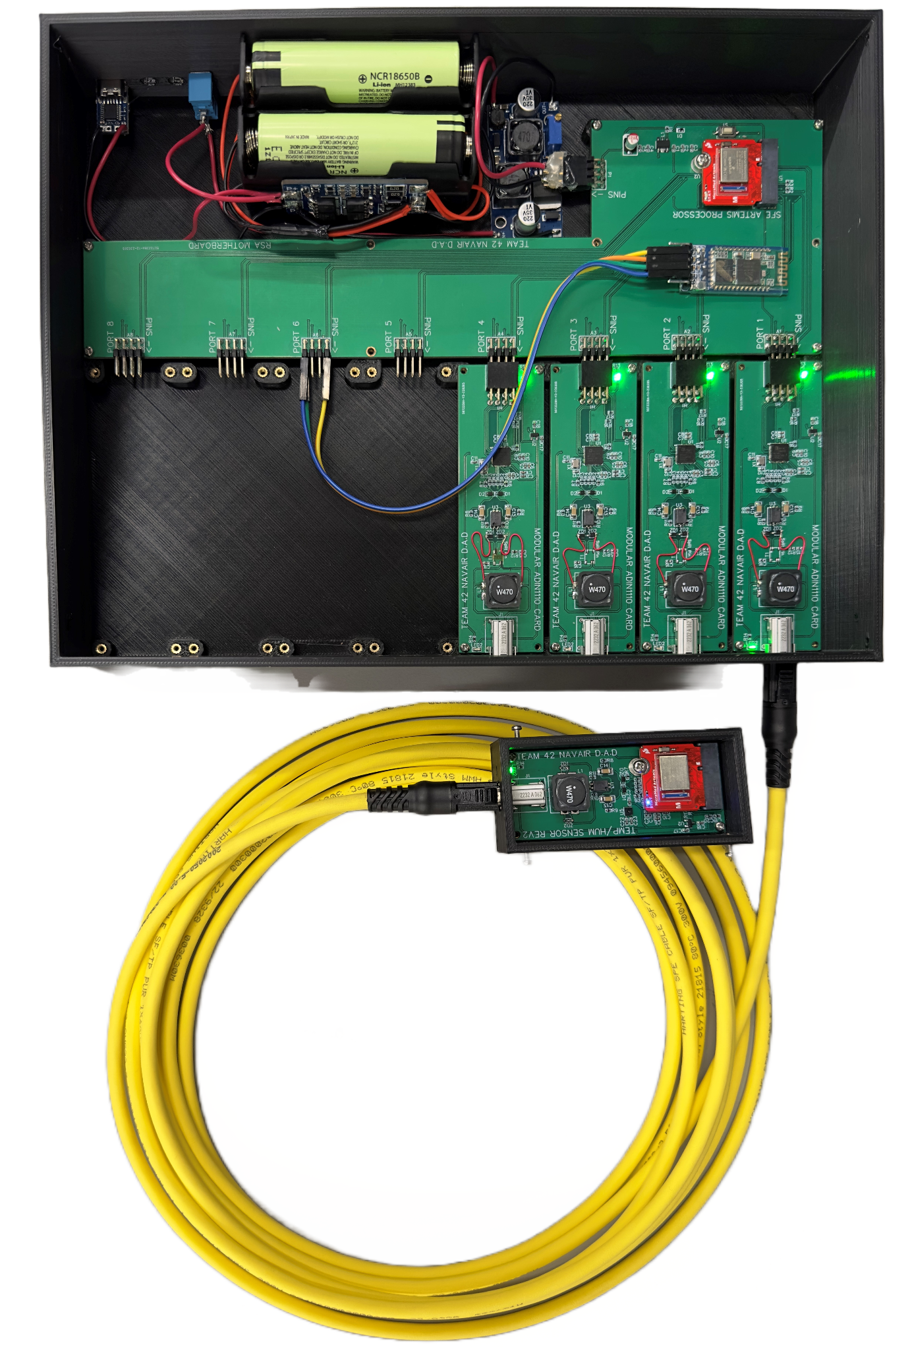

**Terminology Used 3**

**Problem Analysis 4**

Objective 4

Key Requirements 4

Key Constraints 4

Engineering Standards 4

**Detailed Design 6**

Final Design 6

Overview 6

Remote Sensor Array (RSA) 6

Bluetooth Transmission 8

Handheld Device 9

Enclosures 11

Specifications 13

Test Cases 16

Test 1 - Temperature Sensor Test 16

Test 2 - Humidity Sensor Test 17

Test 3 - Sound Sensor Test 17

Test 4 - Vibration Sensor Test 18

Test 5 - Power Systems Test 19

Test 6 - Bluetooth Test 19

Test 7 - Enclosure Test 20

Test 8 - GUI Test 21

Test 9 - General Device Test 21

Test 10 - Sensor Mounting Test 22

**Build & Test 23**

Project Status/Results 23

Test Results and Analysis 25

Key Accomplishments 26

**Delivery 27**

Project Performance 27

Customer Satisfaction 27

Deliverable Status 27

Schedule 27

Cost Status 28

Budget Issues 28

Challenges/Lessons Learned 29

# Terminology Used

| Term | Definition |
| --- | --- |
| Data Acquisition Device (DAD) | Refers to the system at large. Includes all components of the design. |
| Remote Sensor Array (RSA) | Refers to the portion of the device that will be on the aircraft. Sends wireless sensor data to the Handheld device. |
| Handheld Device | Refers to the portion of the device that will be carried and operated by the user. Processes and outputs sensor data to the user. |
| Commercial off the Shelf (COTS) | Refers to commercial devices/products that were purchased from a manufacturer, rather than being custom designed by the team. |
| Single Pair Ethernet (SPE) | Refers to the ethernet standard used for communication with the sensors |
| Modular Card | Refers to the custom board that facilitates SPE communication with the sensors |
| Motherboard | Refers to the custom main board in the RSA which facilitates communication with up to 8 modular cards. |
| Human Machine Interface (HMI) | Refers to, in the case of the DAD, the touchscreen and GUI that the user interacts with |

# 

# Problem Analysis

## Objective

Develop a system for ground technicians to collect, wirelessly transmit, and display maintenance metrics for a grounded aircraft.

## Key Requirements

The following are the key requirements for the device as requested by the customer at the beginning of the project:

* D.A.D. must have Temperature, Vibration, Audio, and Humidity Sensors
  + Sensors must be hot-swappable
* D.A.D. must have sensors connect to wireless transceiver via cables
  + Sensors must be powered remotely via these cables
* D.A.D. must receive wireless data on a handheld device
* D.A.D. must store sensor data to removable medium
* D.A.D. must output data to touchscreen in a digestible form
  + D.A.D. shall have average intensity graphs for vibration and sound
  + D.A.D. shall display FFTs for vibration and sound
  + D.A.D. shall display current temperature and humidity
* D.A.D. must be battery powered

## Key Constraints

The following are the key constraints provided by the customer relating to key requirements of the design:

* Temperature and Humidity at least once per second
* Audio and Vibration up to 5 KHz
* Cable length between 25 and 65 feet
* Battery must last at least 4 hours
* Wireless range shall be at least 50 feet
* Temperature sensor shall max out at 100C
* Humidity sensor shall max out at 100%
* Handheld Device shall be no larger than 8” x 6” x 3”

## Engineering Standards

Standards we identified at the beginning of the project that we aimed to adhere to were FCC Title 47, pertaining to radio transmission, and IEEE 1725-2021, pertaining to rechargeable batteries. All parts of the design relating to these two standards were COTS parts. As such, it is believed that both standards are met, however it should be noted that no investigation was conducted to verify compliance of these COTS parts.

# 

# Detailed Design

## Final Design

### Overview

The final design consists of two main subsystems, the RSA and the Handheld Device. The RSA is placed on the aircraft and consists of custom design sensor boards (Temperature/Humidity, Vibration, Accelerometer, and Microphone) as well as custom designed boards for communicating with the sensors, packaging the data, and wirelessly transmitting the data over Bluetooth. The RSA also contains a battery power system consisting of COTS boards. The Handheld Device is the main point of interaction for the user. It consists of a microcontroller for receiving wireless data, a microcontroller running custom control software, a microSD card module, a touchscreen, and a battery power system.

The following block diagram details system wide inputs and outputs, as well has how the respective subsystems interact internally:

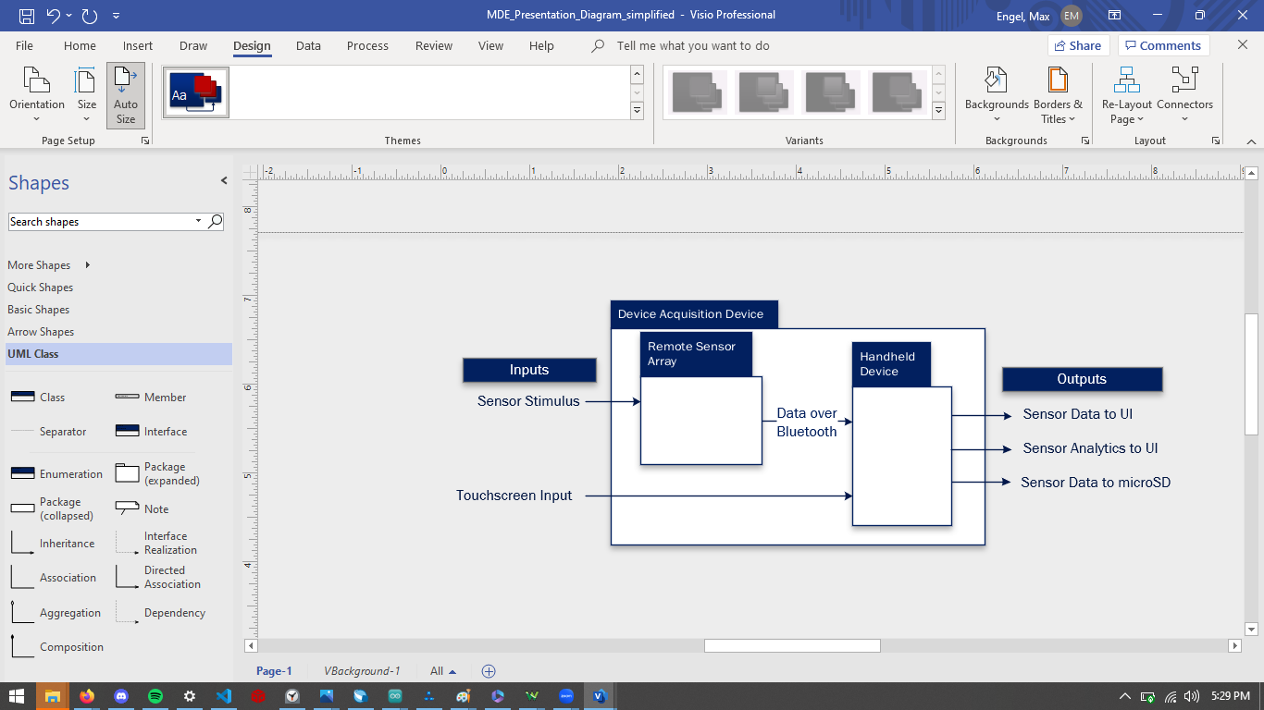

### Remote Sensor Array (RSA)

The RSA is responsible for gathering data from the sensors and wirelessly transmitting that data to the Handheld Device. We chose the Artemis microcontroller due to its support for the Single Pair Ethernet drivers. For the communication protocol between the sensors, we needed a standard that supports remote power for the sensors, is fast enough, hot-swappable, and can transmit over cables 50ft in length. For this, we chose the 802.11cg standard, better known as Single Pair Ethernet. To communicate using this standard we chose the ADIN1110 from Analog Devices. This chip translates our Artemis’ SPI data into SPE data that is transmitted between the RSA’s modular cards and sensors. Since the ADIN1110 is a relatively new chip, we needed to create a custom board that would support the chip itself in addition to the power coupling circuitry. This modular card can be seen here:

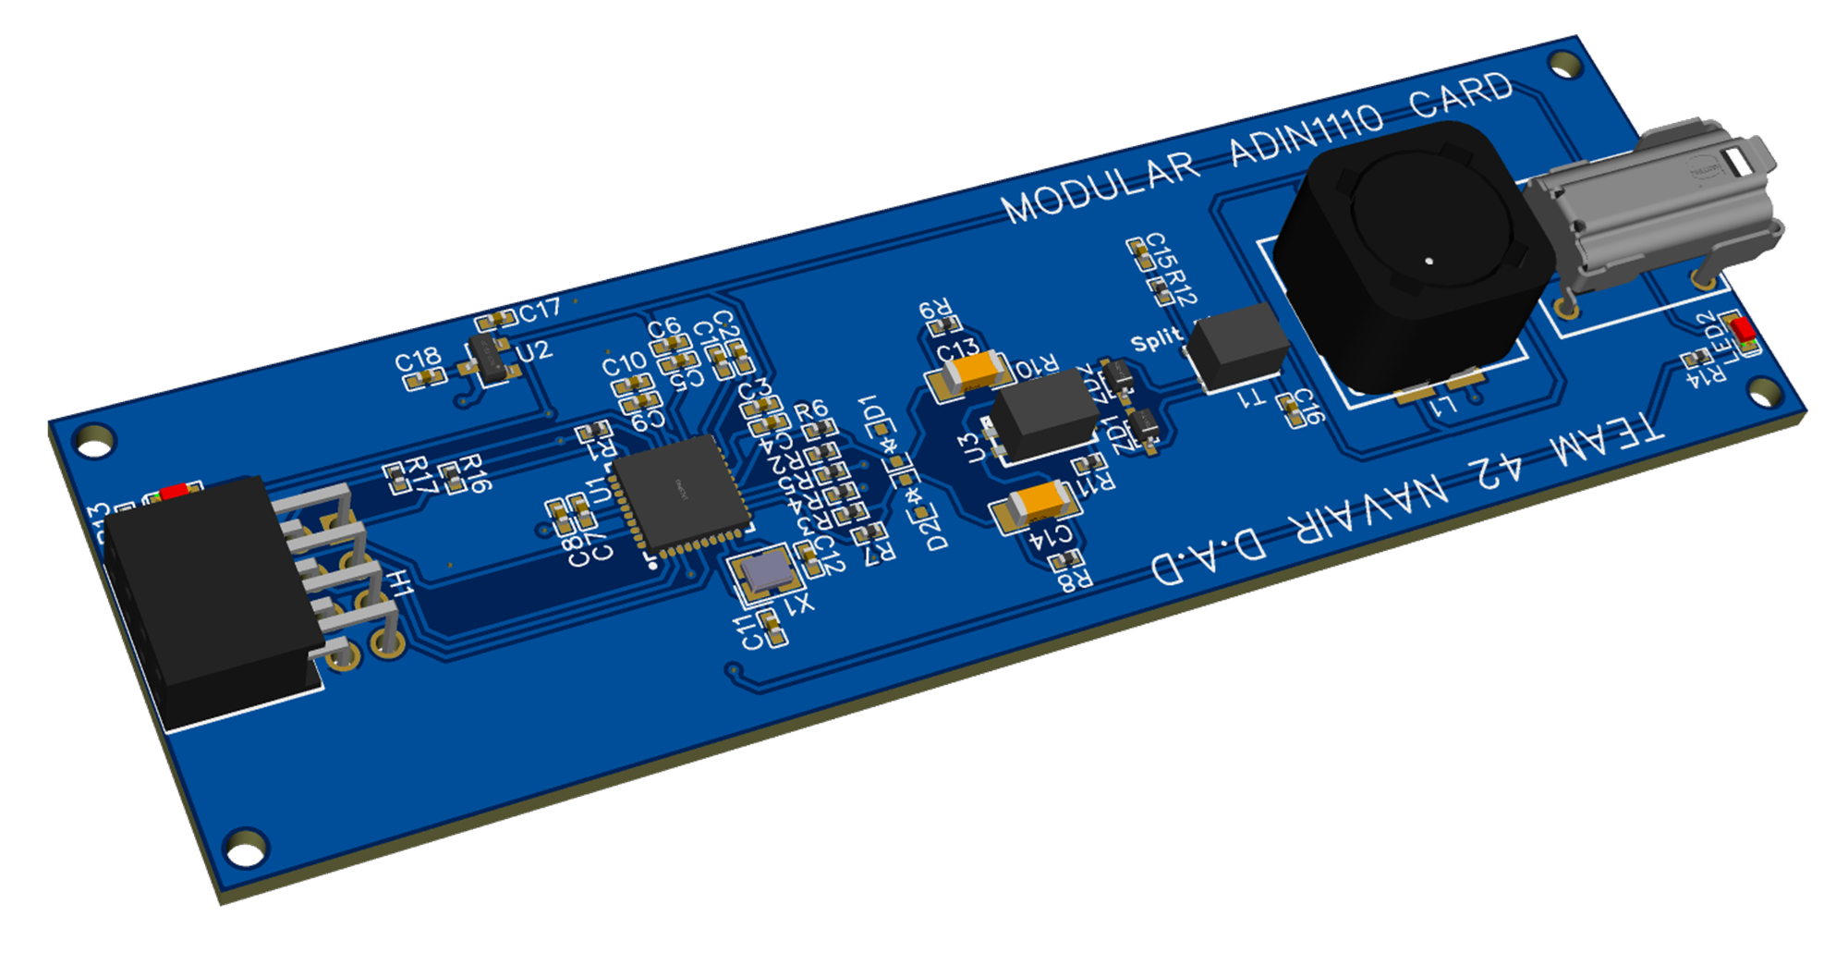

Initially, the isolation transformer on these boards was causing problems. To rectify this issue, we removed this component from our final build since it was not a necessary component. To support up to 8 sensors simultaneously, we needed another custom board, dubbed the motherboard, that would support 8 of our custom ADIN1110 boards in addition to an Artemis. The motherboard can be seen here:

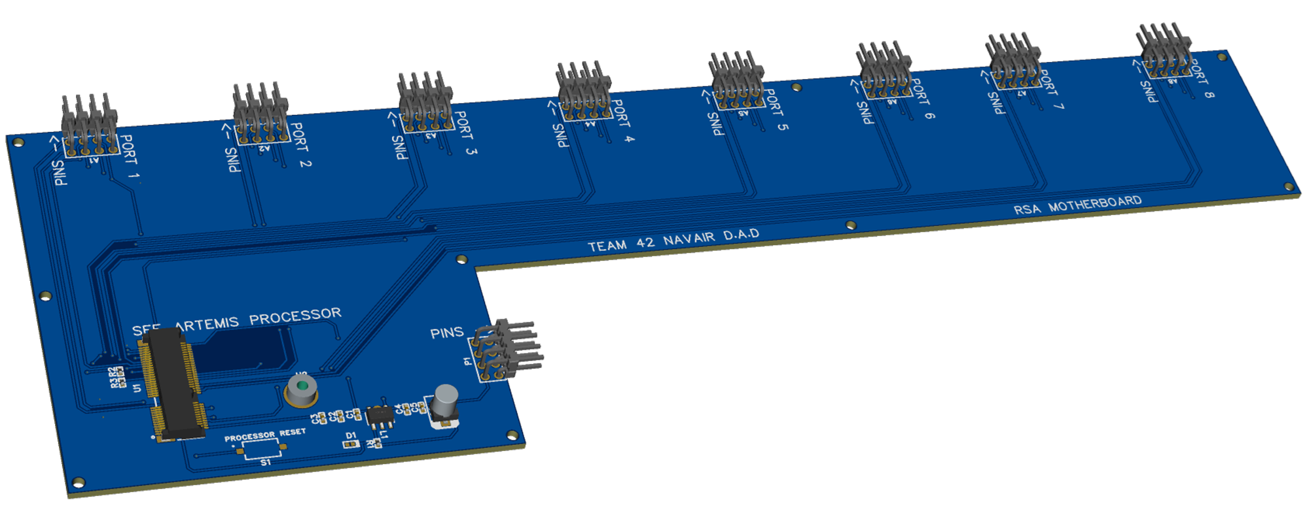

The motherboard uses an Artemis microcontroller to gather the data from the sensors, package it, and transmit it to the Handheld Device via Bluetooth. The sensor boards for the RSA were designed around four different types of data: temperature, humidity, audio, and vibration. The sensors used were the SHT30 Temp/Hum sensor, the IIS2DH accelerometer, the Knowles BU-23173 vibration transducer, and the Adafruit Electret Microphone Amplifier. There are two versions of the sensor boards, with the initial version having communication issues. Communication between the Artemis microcontroller and the ADIIN1110 did not work due to flipped SDI and SDO pins. Additionally, the ADIN1110 chip on these sensor modules would not connect to those on the modular cards. Revision 2 of the sensor boards rectified the circuit issues by using the proven circuitry of the modular card with the sensors added on. All sensor boards look very similar, with only the sensor component differing. Below, our temperature/humidity sensor can be seen:

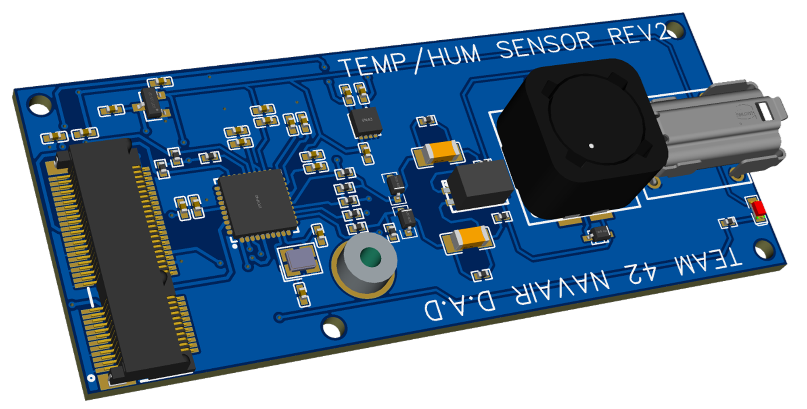

Each sensor board utilizes an Artemis microcontroller for reading the sensor data, and transiting it via SPE. Additionally, the accelerometer, vibration, and microphone sensors utilize the on board microcontroller for performing the FFT calculation. Performing this calculation on the sensor frees up the motherboard’s Artemis so it only has the package and transmit data.

### Bluetooth Transmission

As mentioned, our wireless transmission is performed with Bluetooth. For the RSA, we use a HC-05 module to facilitate transmission. The Handheld Device also uses an HC-05 module for Bluetooth communication.

A custom packet structure was developed for our Bluetooth transmissions:

* + - Data Packet Structure
      * Static size
    - 1 metadata byte, 3 data bytes

| PPP | SS | TTT | Data | Data | Data |
| --- | --- | --- | --- | --- | --- |
| Byte 1 (Port/Status/Type) | | | Byte 2 | Byte 3 | Byte 4 |

* First byte
  + 3 bits for port number - 000 -> 111
    - *Cannot be 111 when sending messages*
  + 2 Bits for status
    - Disconnected - 00
    - Connected with data - 01
    - Connected no data - 10
    - Message - 11
  + 3 bits for Packet Type
    - Temperature - 000
    - Humidity - 001
    - Vibration - 010
    - Sound - 011
    - Message: Low battery - 100
    - Message: Other Error - 101
    - Message: Data collection stopped - 110
    - Message: Data collection started - 111
* Vibration and Sound
  + Data sent as 512-point FFTs
  + First Byte - Metadata as described above
  + Second Byte - Index of data (0-25**4**)
  + Third and Fourth Bytes of data - 8-bit decibel magnitudes
* Humidity and Temperature
  + First Byte - Metadata as described above
  + Second Byte - Temperature or Humidity data
  + Third/Fourth Byte - Empty
* Message
  + First Byte - Metadata as described above
  + Second/Third/Fourth Byte - Empty

### Handheld Device

The purpose of the Handheld Device is to receive the wirelessly transmitted data from the RSA, display the information, and store it on a microSD card.

For the Handheld Device, we decided to use the MSP432 microcontroller from TI, as it contained enough interfaces to support all of the peripheral devices required for the device. Rather than implementing a custom solution we used the COTS launchpad from TI:

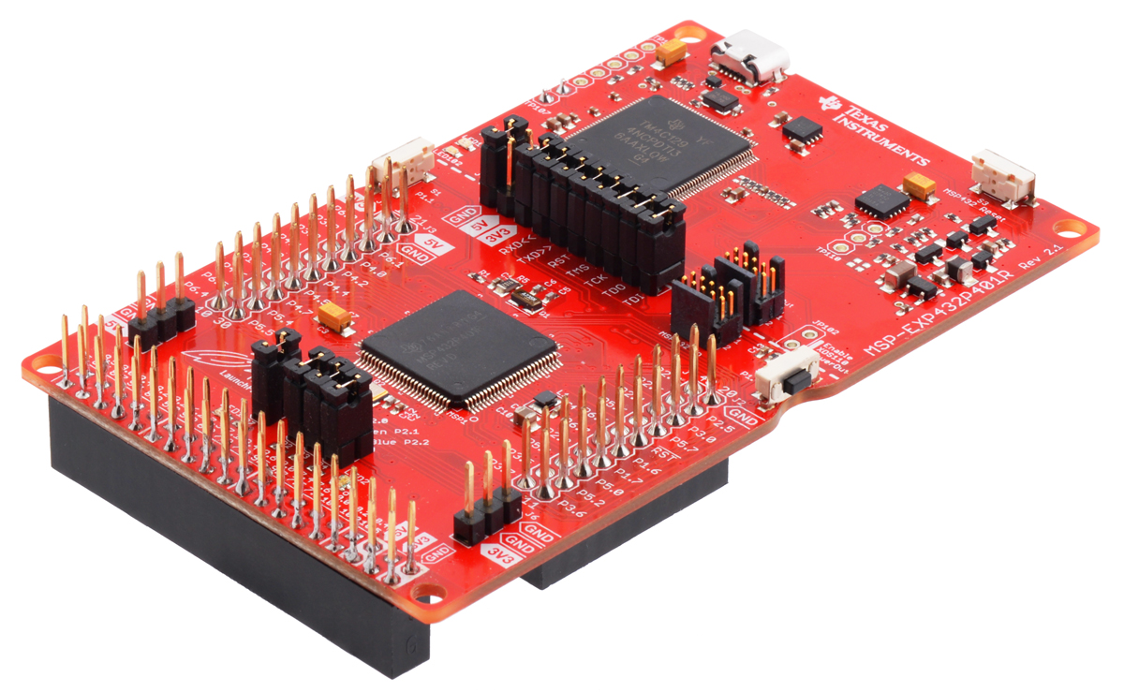

We chose to use a 7” Touchscreen HMI from Nextion as our display, and the SparkFun OpenLog for our microSD module:

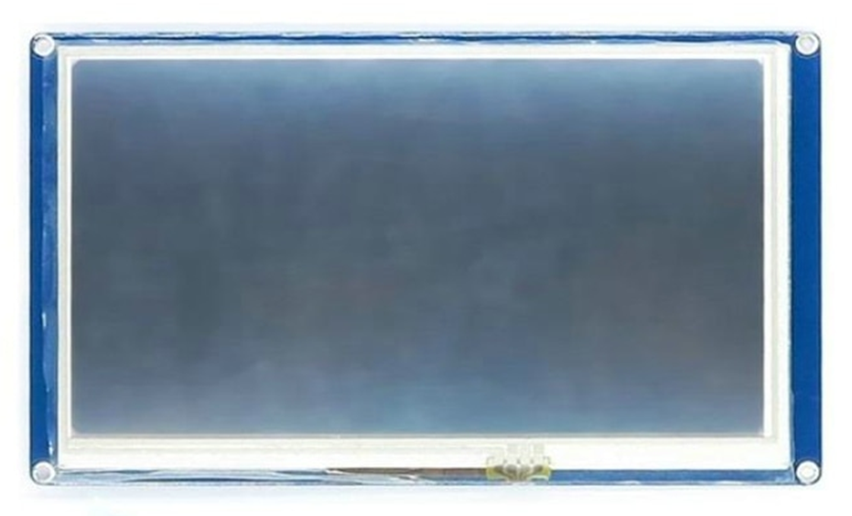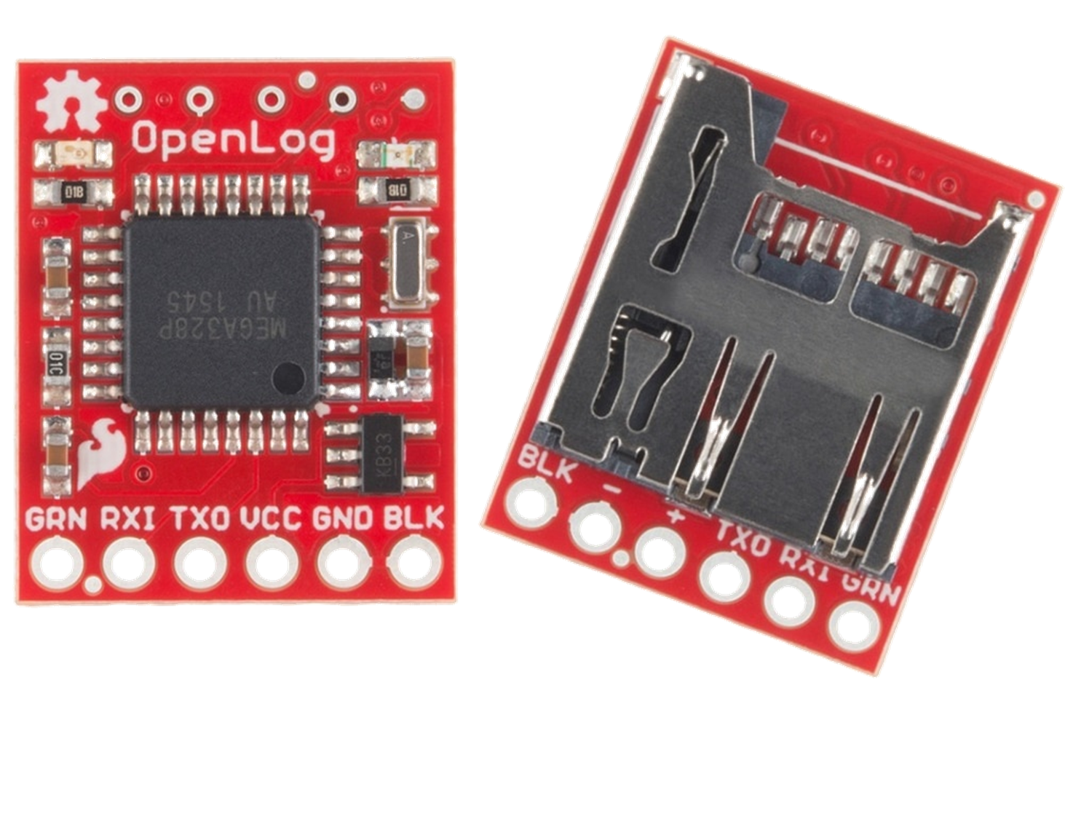

We started familiarizing ourselves with these peripherals by writing basic test code to prove that we could communicate effectively with these devices via UART.

Eventually, we wrote custom HALs and came up with a control scheme. Our control software is written in three levels- the first being the HAL to interface with the device itself. The second involves common functions using the HAL, such as updating the UI or storing an FFT. The third, and most abstracted layer consists of the control scheme. Each block within this control software was tested before being integrated.

As the software grew more complex, so too did our testbenches. In order to develop the Handheld Device control software while the RSA was being developed simultaneously, we created an RSA simulator with Python and an Arduino to generate dummy data packets. To ensure easier integration of the actual devices, we made the simulator provide data to the Handheld Device in the exact same packet structure over the exact same UART interface as the RSA would.

### Enclosures

To house all of the electronics, enclosures were designed and 3D printed. All four custom sensor boards were designed on the exact same PCB footprint, allowing for a single universal enclosure for all, with dimensions 3.1” x 1.5” x 1.1”:

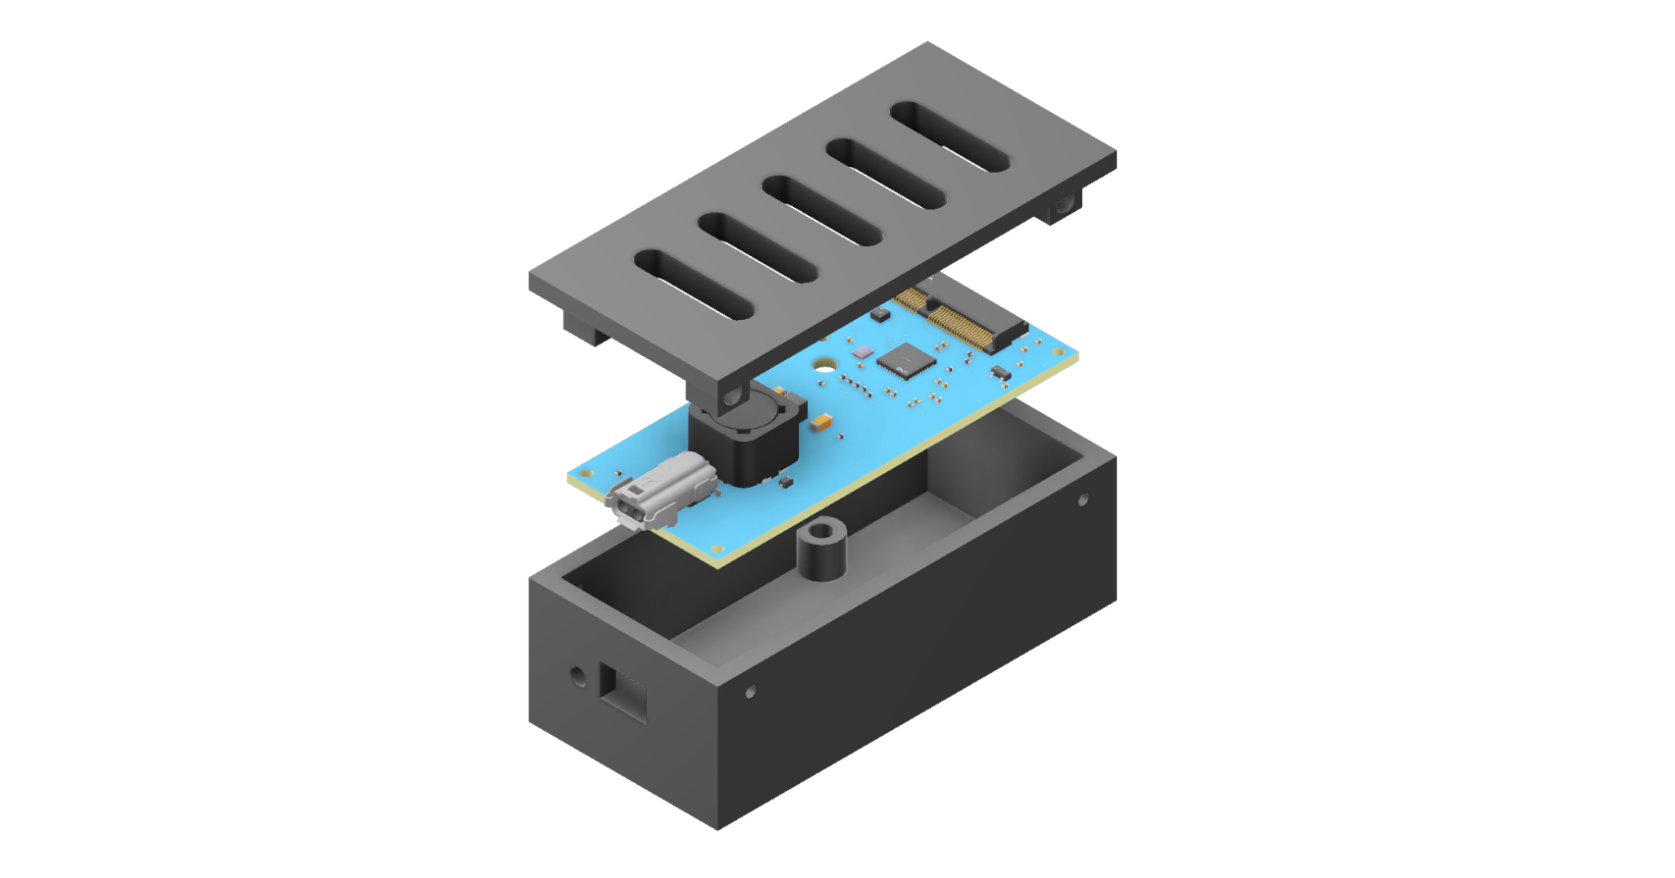

The only exception being that a special lid with a cutout was needed for the microphone sensor to ensure proper audio pickup of the environment: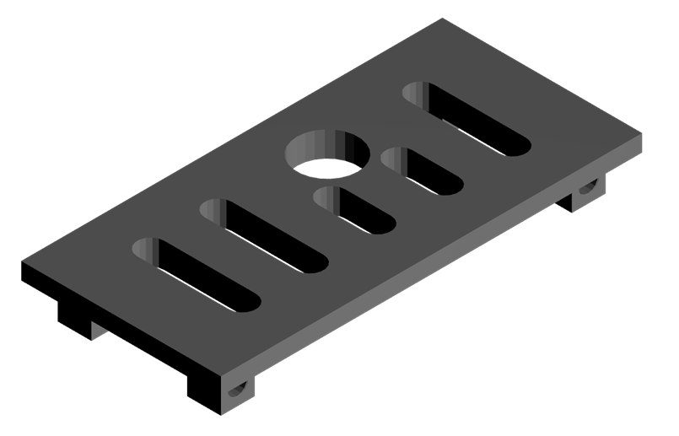



The RSA’s transmission system enclosure was designed to support USB-C charging, status LEDs, a power switch, and ports for connecting up to 8 sensors, with dimensions 10.4” x 8” x 2”:

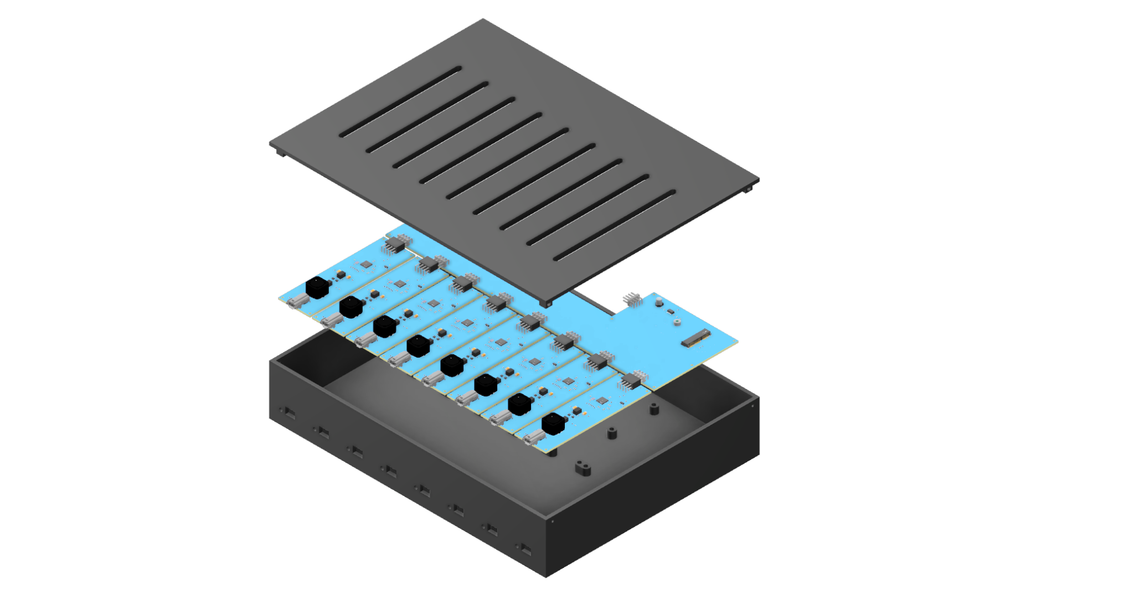

The Handheld Device enclosure was designed to support very similar I/O, with the only differences being the lack of sensor ports and the addition of a screen cutout, with dimensions 8” x 4.6” x 2”:

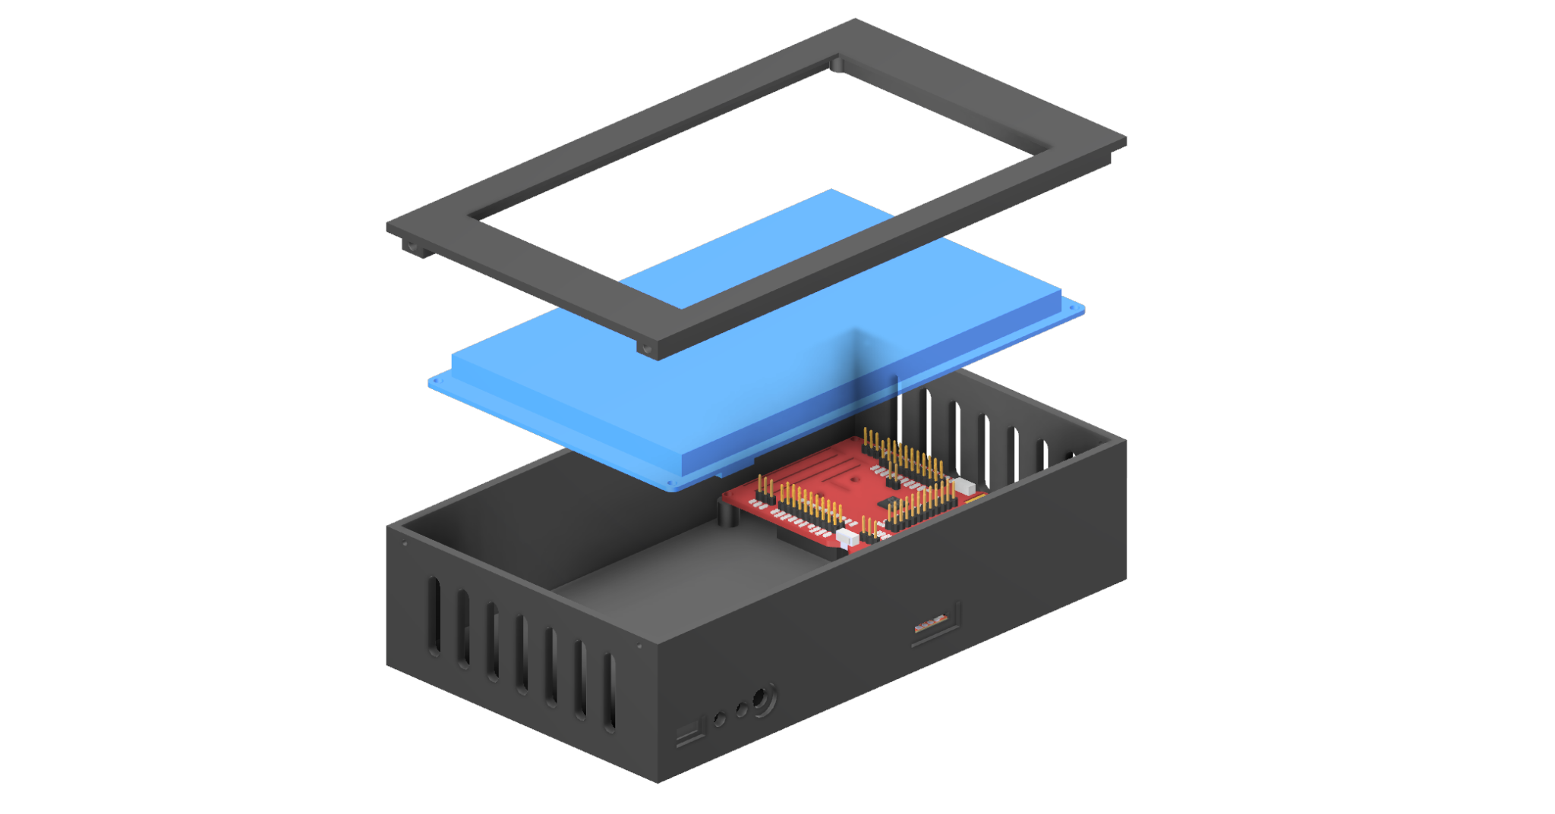

## Specifications

During the early stages of the project, the main focus of the team’s work was dedicated to the translation of customer needs to engineering requirements, and devising appropriate plans for fulfilling those requirements. These customer specifications, defined during several meetings with NAVAIR, can be seen below. We used a priority rating system in order to define requirements and focus our design on the highest priority, with 1 being the highest priority and 5 being lowest. One of the highest-priority customer requirements was the idea of a wireless connection between the sensors and the handheld device. This would allow the user to interact with the system and gather data without needing to be physically aboard the aircraft. Another high-priority requirement was the idea of hot-swappable sensors. This means that the sensors designed could not interrupt device operations if they were added or removed during use. Some other examples of high-priority requirements were those from the previous project - live updating sensors, a detachable storage media containing all acquired data, and a touchscreen with an easily understood GUI.

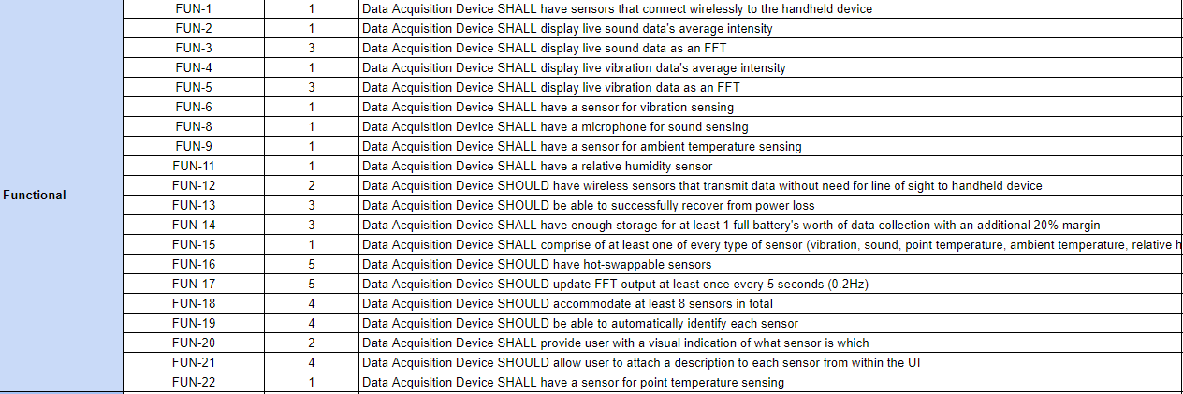

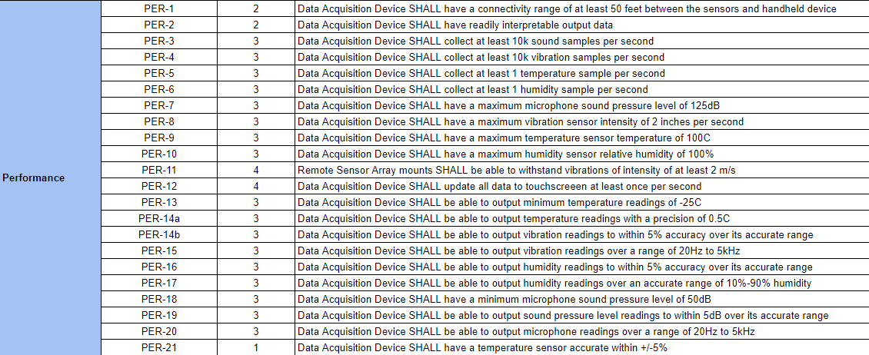

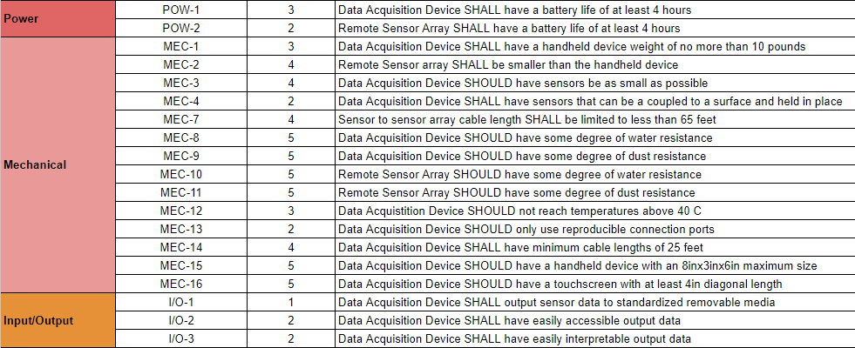

Next, the above customer specifications were translated into engineering requirements. These requirements grouped the many different specifications given by NAVAIR into 28 requirements that we could use to measure the success of the project. These requirements are directly mapped to our customer specifications, allowing us to group similar tasks together to simplify the objective at hand. Adding to this, the engineering requirements were matched with the different tests we developed for this project. Each requirement defined a measurable target for us to reach during development. For this particular table, we used a priority ranking system of 1 through 5, with 1 being the highest priority and 5 being the lowest. Some of our highest-priority requirements include the collection rates of the sensors, as well as the UI elements of the device and the overall function of the device.

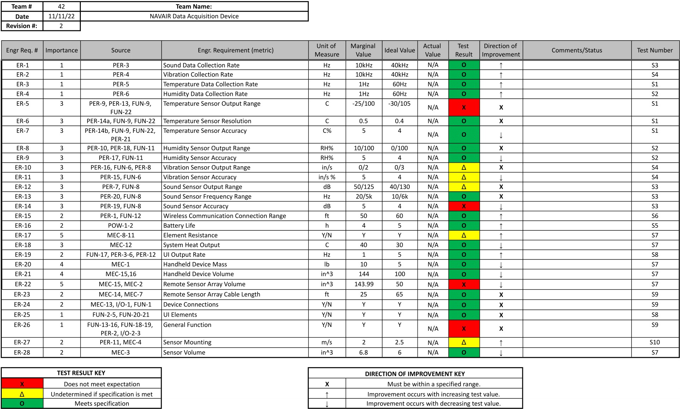

As a final simplification of the given specifications, we created a Target Specifications Table. This table contains measurables that we could use to further define our progress. Not only did they provide a baseline for success, but they also gave target values to aim for which would go beyond the minimum requirements from the customer. The engineering characteristics, seen below, were given a priority rating as well. This priority rating lists the highest priority objectives at 5, with the lowest priority being 1. Two measurables that we defined as high priority had to do with communication. Firstly, the range of the wireless communications, which we set a target value of 50ft. Secondly, the latency of the data for both slow and fast streams. We set our targets at 100ms and 10ms, respectively. Some of the other characteristics that we deemed a priority was having a battery life of at least 4 hours, the data rates of audio and vibration data at 10kHz, and the tolerances of the many sensor types included in the design.

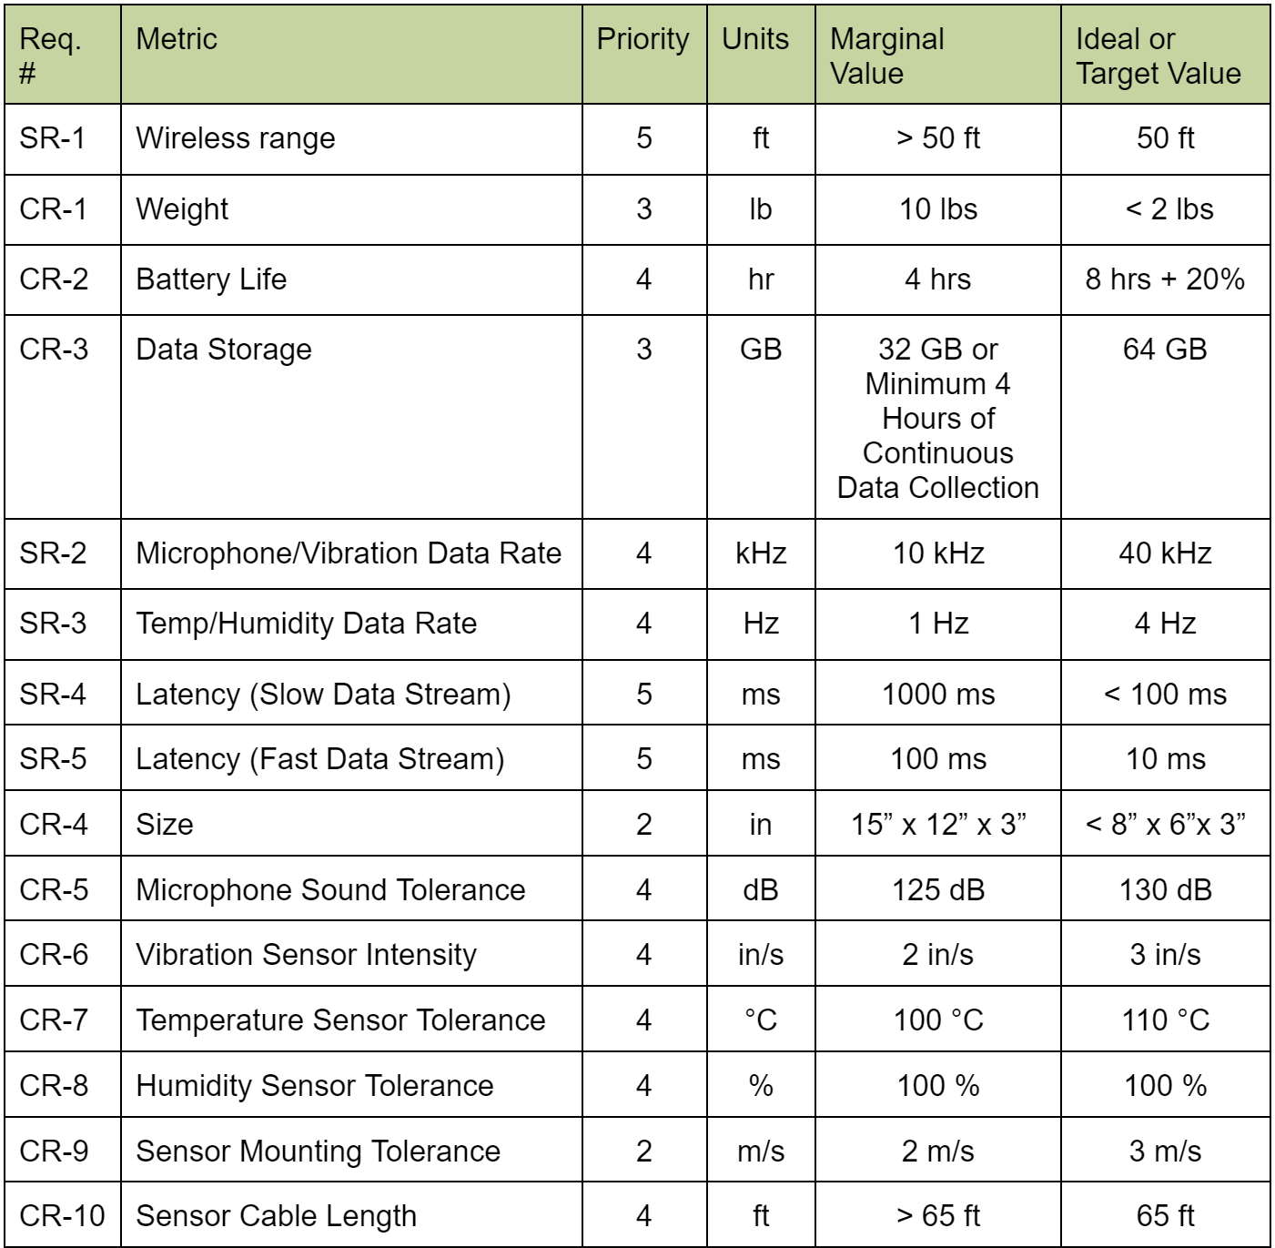

## Test Cases

For device testing, we devised 10 test plans to ensure that all requirements were met.

### Test 1 - Temperature Sensor Test

The goal of this test is to verify that the data provided by the full range of the selected temperature sensor can be read, packaged, and transmitted from the Remote Sensor Array (RSA) to the Handheld Device. The high temperature will be recorded using a toaster oven, while the low temperature will be recorded with dry ice.

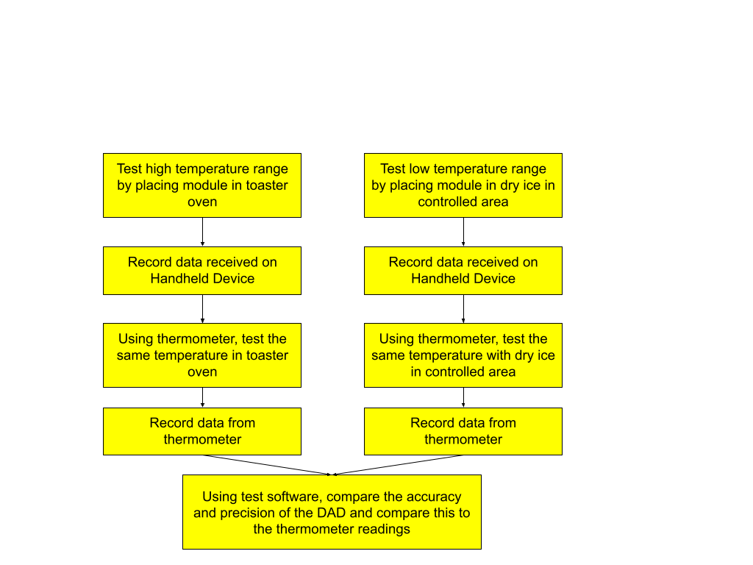

### Test 2 - Humidity Sensor Test

The goal of this test is to verify that the Data Acquisition Device (DAD) system can sense, transmit and record humidity readings at the rate specified by the customer. The DAD will take humidity readings along with an independent humidity sensor. These readings will be compared and validated against the customer requirements.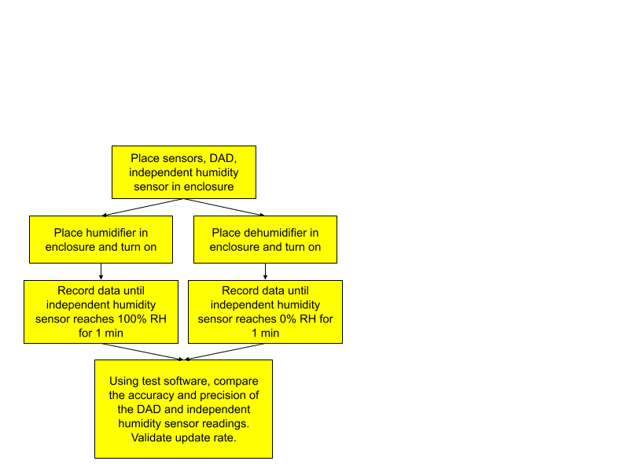

### Test 3 - Sound Sensor Test

Testing and calibration software are prepared. Sound sensor is placed beside a decibel meter in front of a sound emitting device. After calibration, the range of the sound sensor is tested by using the speaker system to emit sound at the maximum and minimum values desired, and the value detected by the sensor is compared against the value detected by the decibel meter. Because the decibel meter has a known accuracy, it can then be used to test the sound sensor's accuracy after calibration. Finally, a tone emitting program is used to test the sound sensor's frequency range.

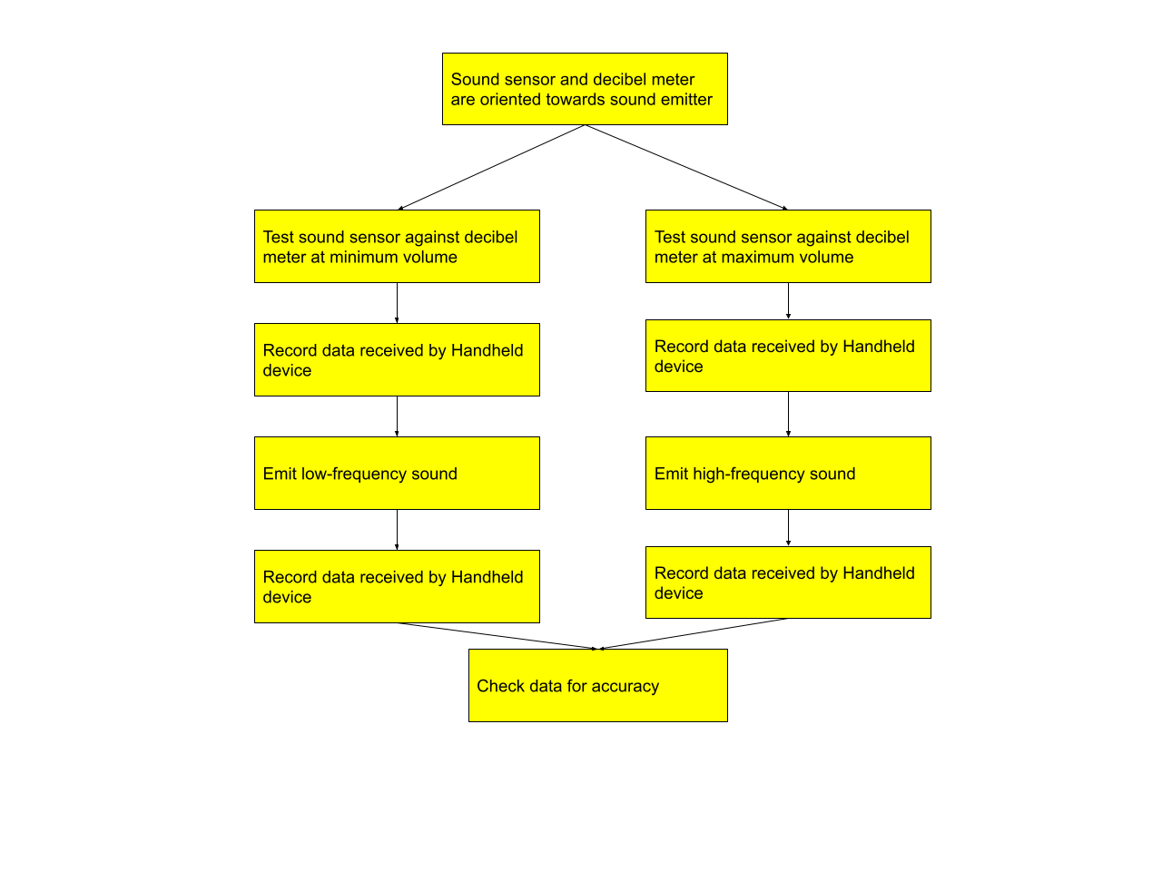

### Test 4 - Vibration Sensor Test

The goal of this test is to verify that the Data Acquisition Device (DAD) system can sense, transmit and record vibration readings at the rate and accuracy specified by the customer. The DAD will take vibration readings along with an independent vibration sensor. These readings will be compared and validated against the customer requirements.

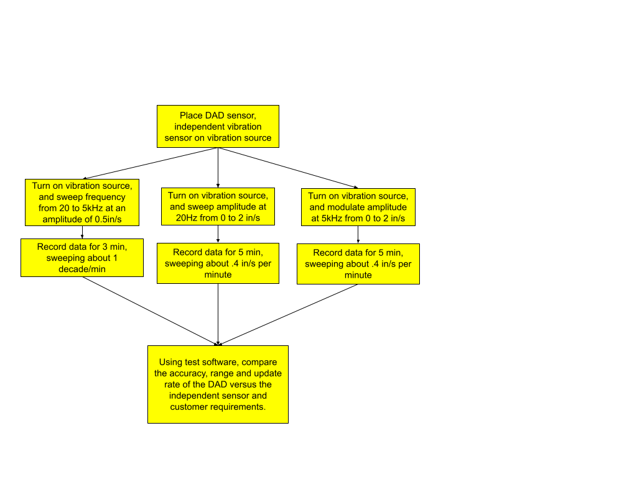

### Test 5 - Power Systems Test

The goal of this test is to verify that the battery life of both the Handheld Device and RSA meet the 4-hour battery life requirement. The full system will operate with dummy data in a loop to keep the system running until either battery is fully depleted. The time will be recorded with a stopwatch.

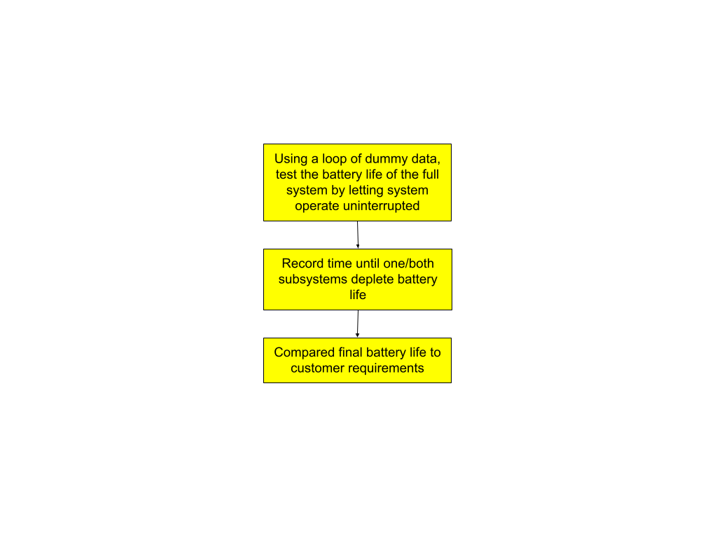

### Test 6 - Bluetooth Test

In order to ensure the system meets wireless communication range requirements, connectivity between two Artemis microcontrollers is established, and data is transmitted at a range of 50 ft. Provided data integrity is maintained, range is then increased until limits are discovered.

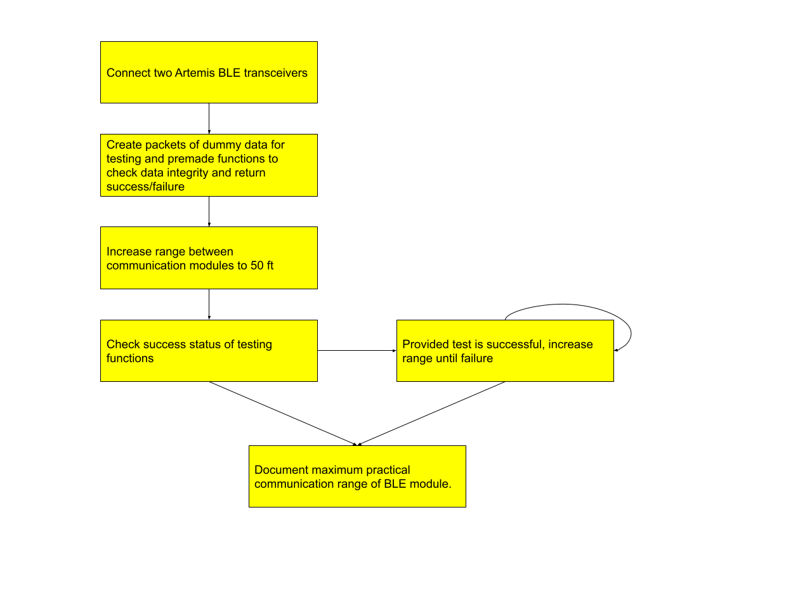

### Test 7 - Enclosure Test

The goal of this test is to ensure the system meets all mechanical requirements. This includes size, weight, and resistance to the elements.

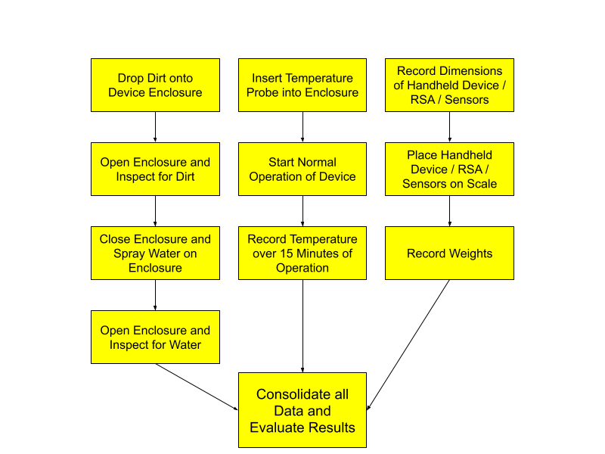

### Test 8 - GUI Test

The goal of this test is to verify that the GUI is refreshing the data it displays at quick enough rates. By video taping the GUI while the device is under operation, we will be able to scrub through the frames of the video recording to ensure that our refresh rates are met.

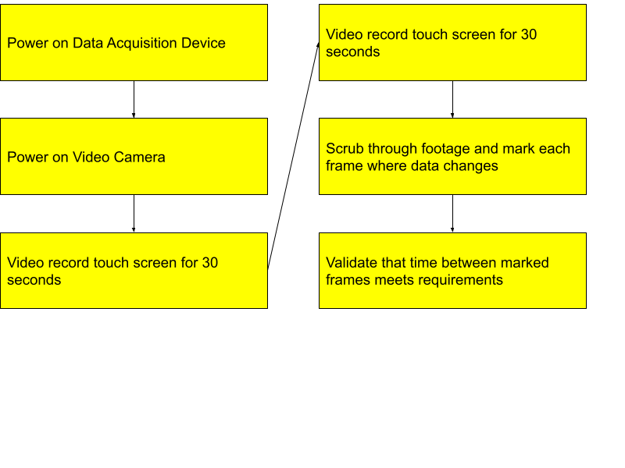

### Test 9 - General Device Test

The goal of this test is to ensure our cables meet the specified requirements for length, we have 8 ports, and that the device operates properly.

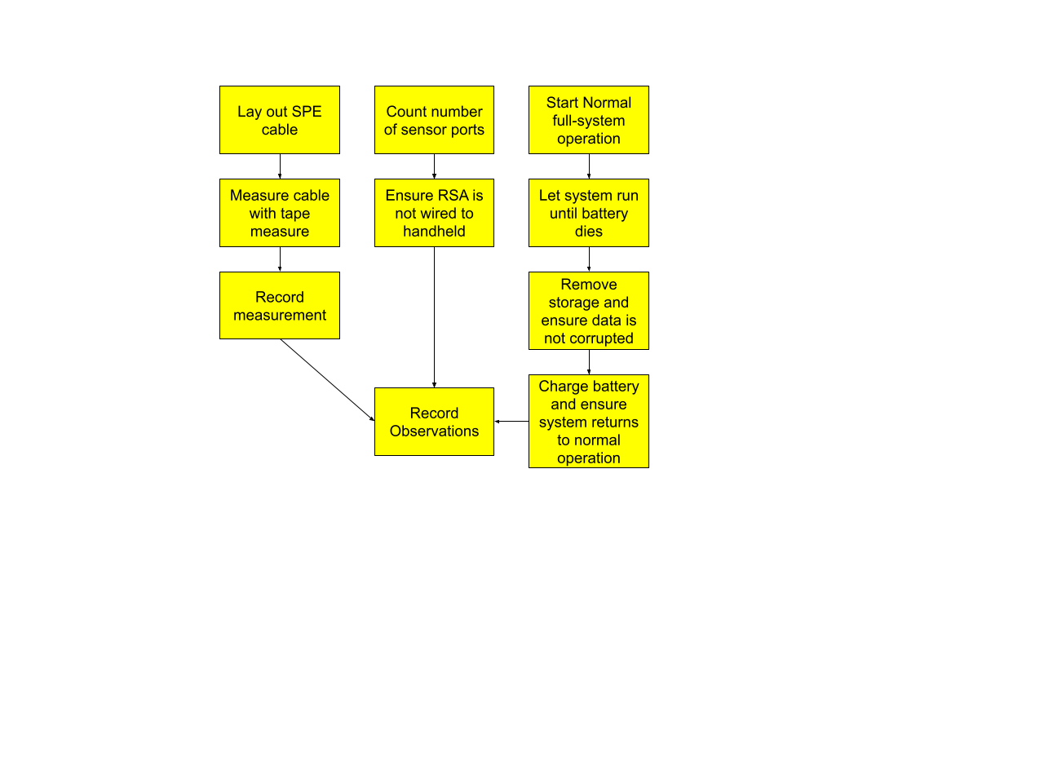

### Test 10 - Sensor Mounting Test

The goal of this test is to ensure our sensor mounting is up to specification. Using an Atwood machine, we will mount the sensor to the machine and generate a constant acceleration that we can ensure the sensor stays mounted during.

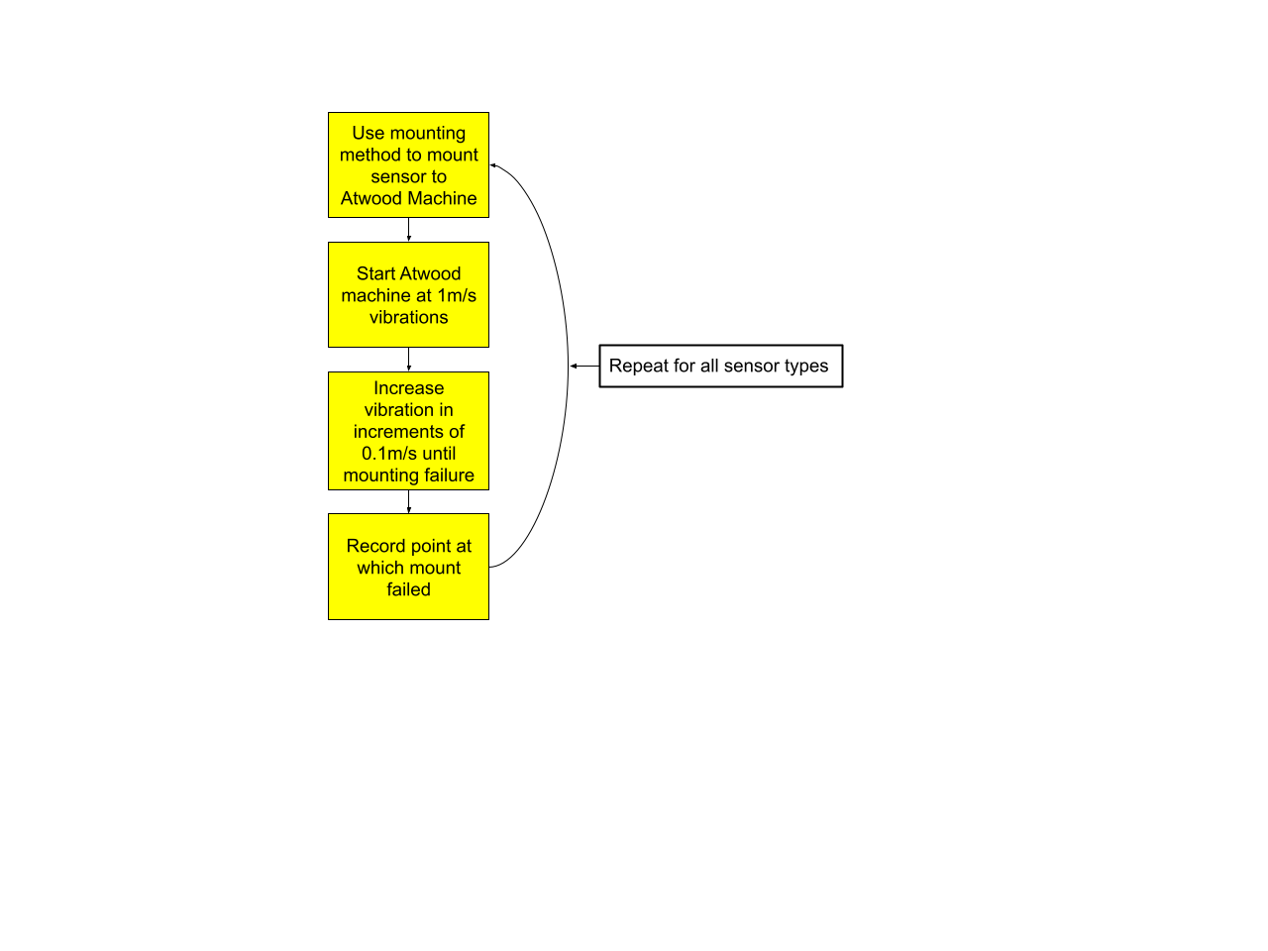

# 

# Build & Test

## Project Status/Results



*RSA with Temperature/Humidity Sensor Attached*

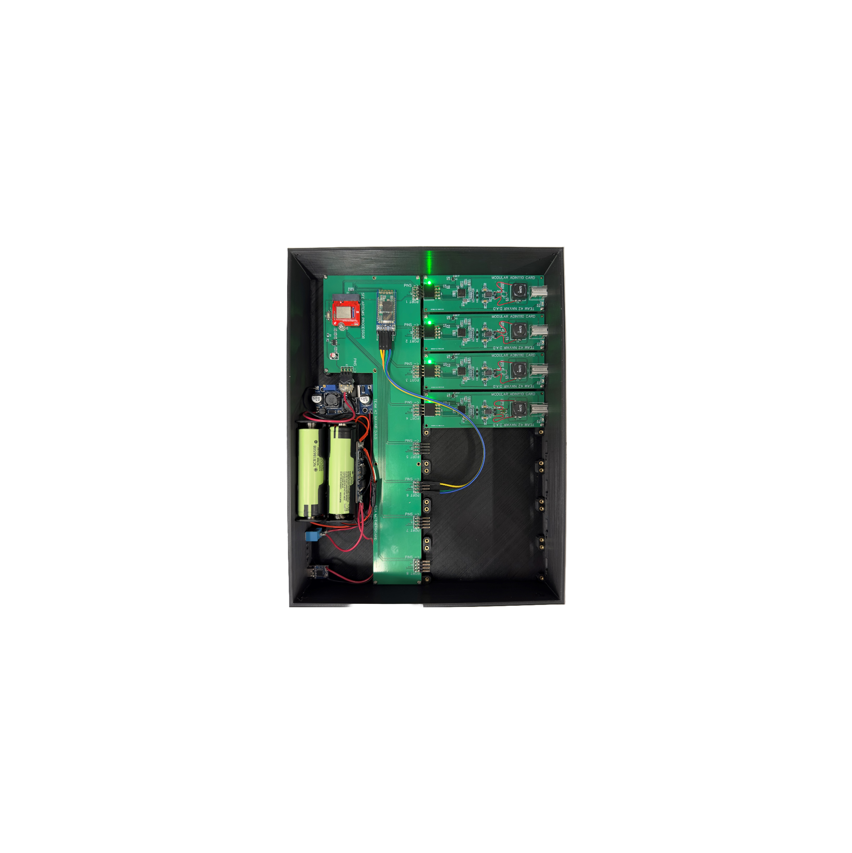

*RSA Motherboard with Power System and Modular Cards (Cover Removed)*

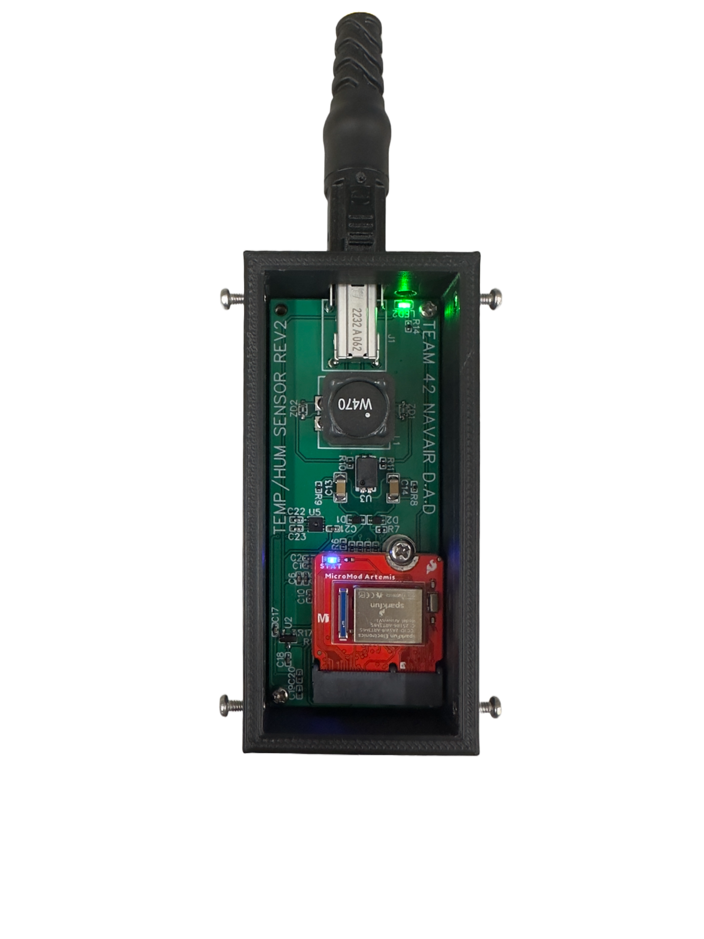

*RSA Temperature/Humidity Sensor (Cover Removed)*



*Handheld Device Displaying Simulated Dummy Data over UART*

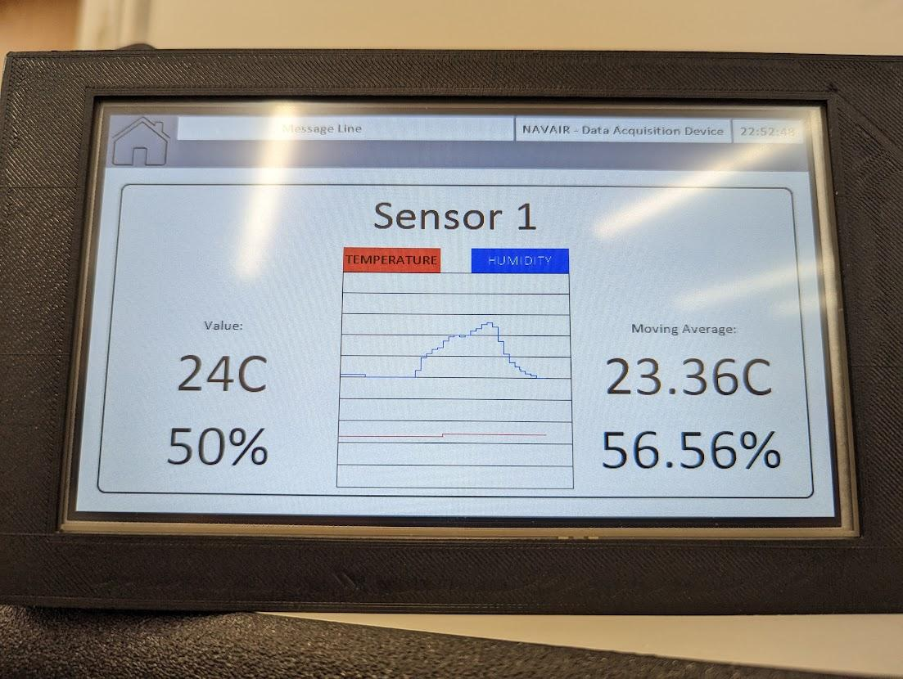

*Handheld Device Displaying Real Time Temperature and Humidity Data*

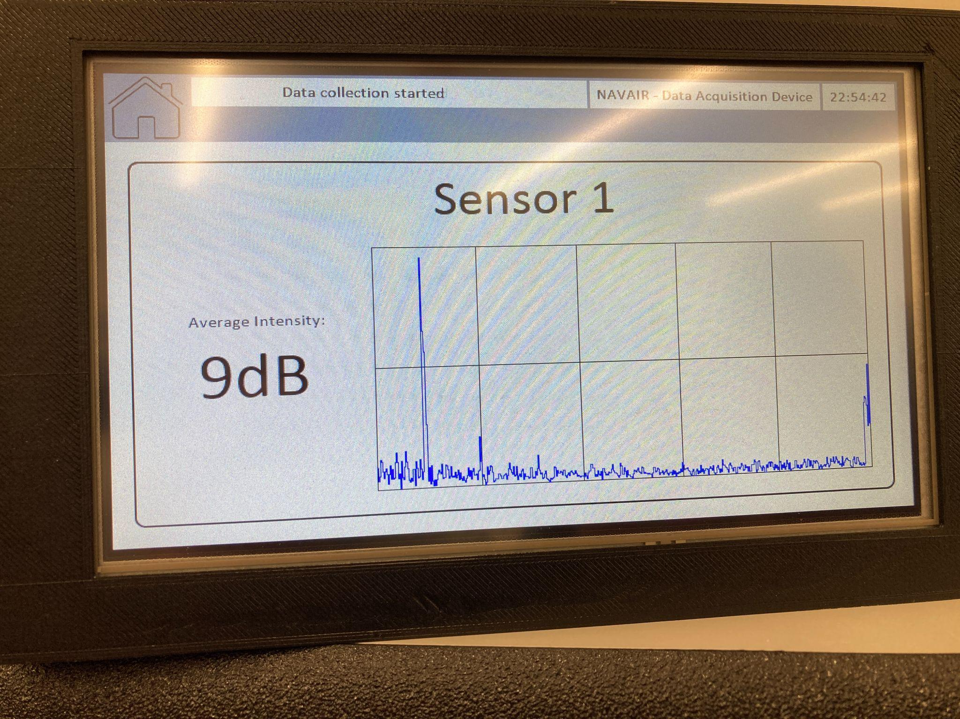

*Handheld Device Displaying 512-Point FFT performed on live sound data*

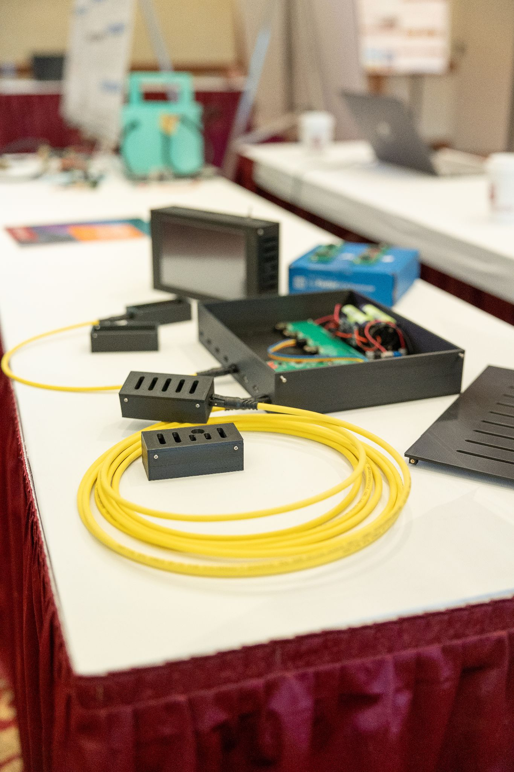

*Data Acquisition Device at Expo*

## Test Results and Analysis

Unfortunately, due to many budget and time constraints we were not able to follow through on much of the formal testing as described above.

The sensor tests encompassing the temperature, humidity, sound, and vibration sensors were not completed. Though the functionality of the temperature, humidity, and sound sensors can be seen through the pictures above, no testing was done in a formal setting. The testing on the temperature/humidity sensor involved putting a thumb near the temperature/humidity sensor and tracking the output change in temperature/humidity. Testing on the sound sensor involved playing waveforms at known frequencies and reading the output FFT to see if it displayed harmonics at the right frequencies.

The power systems test was not completed in a formal setting, but a rough estimate for the lifespan of both devices can be given. The RSA’s lifespan can be determined by dividing the overall capacity of the battery, in this case 6800mAh, by the estimated current draw of the device, roughly 800mA for eight sensors. This estimated value is based on the current draw when testing two sensors. With that, the RSA has an estimated 8.5 hours of battery life, well exceeding the customer requirement. The Handheld device, however, does not meet the requirements, with a rough estimate from testing of about 2 hours.

The bluetooth test was completed, but not in a formal setting. The devices were spaced out at about 60ft (as measured by paces) before disconnecting. At the edge of their range, the Handheld Device kept updating with data from the RSA.

The enclosure test was not completed.

The GUI test was not completed as specified. Rather than video recording the handheld device and counting the frames, we just counted the time between FFTs using the RTC display. The FFT output regularly updates within 4 seconds. The temperature and humidity sensor died before we could do formal testing.

Parts of the General Device Test were completed as specified. The device runs and collects data nominally until the battery runs out. Data output to microSD is not corrupted. As specified, further runs do not overwrite old data.The cable length portion of this test could not be completed due to budgetary constraints. The sensor port portion of this test could not be fulfilled.

## Key Accomplishments

While not all requirements of the project were met, many fantastic accomplishments were made in developing this complex device:

RSA Sensor Board Accomplishments:

* Microphone sensor fully working
* Sensors do not contain batteries and are powered remotely
* Sensors are uniform in size giving a cohesive look
* Temperature/Humidity sensors report accurate data
  + This was verified, then a voltage regulator on board failed rendering the sensor dead
* FFTs are successfully calculated on the sensor itself
* Able to send data via SPE to RSA transmission system

RSA Transmission Boards Accomplishments:

* Custom boards (motherboard/modular cards) are functional
* Able to transmit via Bluetooth
* Able to receive sensor data via SPE
* Able to power sensor boards via SPE
* Device is battery powered

Handheld Device Accomplishments:

* Data updates on screen
* Data is saved to microSD card
* Up time since device flash saved to microSD card
* Sensors can be renamed via on-screen keyboard
* Device shows current time
* Data updates can be paused/resumed
* Dimensions are within constraints
* Able to receive data via Bluetooth
* Device is battery powered

# Delivery

## Project Performance

The performance of the project was well received by many parties at Expo. People who came and spoke with us at our poster session expressed that they were impressed with our implementation, despite the specification not met. The team struggled to perform flawlessly when it comes to administrative tasks, like budgeting and scheduling. Despite these challenges, the team worked very hard to rectify issues that arose, such as the budget limit hit in early March. While not perfect, the team demonstrated exceptional effort to progress through the project.

## Customer Satisfaction

The customer has expressed satisfaction with our project performance throughout both semesters of MDE. While not all requirements were met, this project has shown a significant improvement from the previous team's implementation, specifically in making the device wireless. Based on this revision's success, the customer expressed at Expo interest in moving forward with another revision of this project.

## Deliverable Status

Our project has been fully manufactured and will be handed to ECE faculty for delivery to the customer. All parts purchased with ECE department funds that were not used in the final design, such as development boards, will also be returned back to the ECE department.

The deliverable meets most specifications with the only major exception being that only one port is active on the RSA and only the microphone sensor is fully functional and tested.

## Schedule

For final development we created week long sprints to keep on track. While we encountered many obstacles along the way that ended up changing our schedule, we constantly adjusted to complete our goals. A summary of major milestones is as follows:

* 8/22/2022 - Start of Fall 2022
* 10/20/2022 - PDR
* 11/28/2022 - CDR
* 1/17/2023 - Start of Spring 2023
* 3/23/2023 - Project Demo
* 4/19/2023 - ECE MDE Expo

## Cost Status

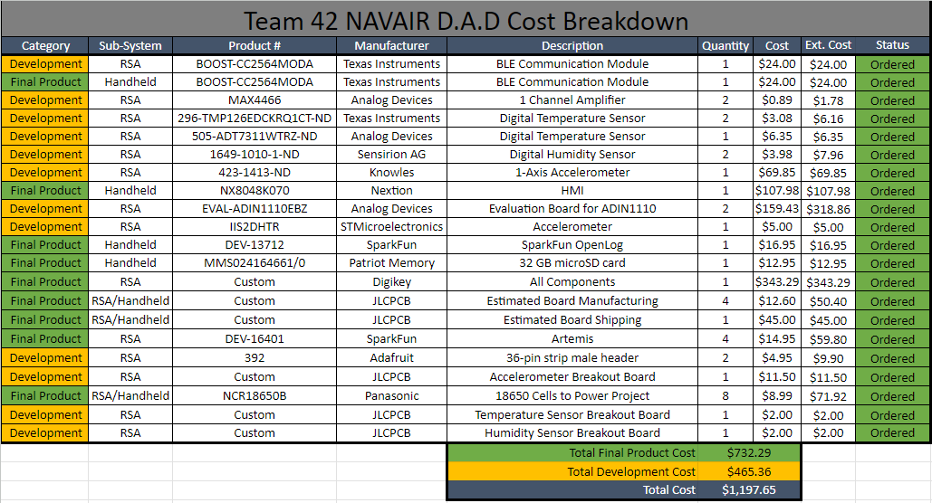

## Budget Issues

One of the biggest issues we came across during the design process was our budget. The combination of both expensive development boards and custom hardware pushed our budget higher than expected. By the time the team was ready to send out the custom hardware for manufacturing, we were already beyond an acceptable cost for the overall project. We were able to secure enough funding to produce the custom hardware, with some cuts made to the overall design, but that would be the strict limit set by the department for this project.

As mentioned above, some changes were made to the overall design in order for the overall cost to meet that strict budget limit. Per the customer requirements, the RSA needed to support up to 8 individual sensors. We had planned to produce 8 sensors and matching modular cards in order to demonstrate the device’s full capabilities. However, this was reduced to 4 individual sensors and modular cards, as the cost of parts would’ve exceeded our newly set budget. In addition to this, we had planned to have separate sensor boards for temperature and humidity. This was reduced to a single board which worked out well, since the Sensirion SHT30 supports both temperature and humidity. One final change made to the design was the removal of a custom power system. The system consisted of the STMicroelectronics STUSB4500, a USB-C Power Delivery chip that could supply 9V of power, as well as the Texas Instruments BQ25306, a Lithium-ion battery charging chip. As mentioned above, the budget issues were dealt with as we prepared to send out PCBs for manufacturing, so this power system has been fleshed out to the point of having its own PCB designed.

While the custom power system was not a necessity for this project, it was seen as an improvement over the previous team’s design. It also fit the idea that we had decided to aim for with this project. We wanted to test ourselves and take a risk by designing custom hardware rather than depending on COTS parts. Of course, given the budget issues, this was not possible for the full extent of the design. Our final design includes a power system that is made entirely of COTS parts. It is dependable enough, though there are some issues with these parts, as they aren’t the quality parts that would compliment a project like this.

Though the budget issues were not detrimental to the overall success of this project, they did provide good lessons to be learned. A bigger emphasis needed to be put on the budget, and we needed to plan around our budget better than we did. Additionally, the budget issues that developed needed to be noticed and addressed much sooner than they were.

## Challenges/Lessons Learned

The first revision of our sensor boards had issues. And though the second revision of the sensor boards not only worked properly, but also allowed us to make significant improvements to the layout, it cost us precious integration time that would’ve been useful at the end of this production phase. We learned that peer reviewing PCB’s is necessary to ensure that the boards being produced will function properly.

While developing the RSA, driver issues were encountered. The Artemis’ Bluetooth drivers did not work reliably with its SPE drivers. The SPE drivers were not written to deal with multiple SPE chips. Ultimately, Bluetooth was offloaded from the Artemis in order to ensure the SPE drivers worked. It is important to understand the capabilities and faults of drivers before attempting to use them.

We initially opted for BLE with the goal of reducing power consumption, however, we discovered that BLE suffers from several issues that would impact the success of our project. These included issues with regards to transmission speed, range, and reliability. Due to their immediate availability and known reliability, we opted to use HC-05 Bluetooth modules instead.

Many of our components communicated via UART. We learned that for real-time data transmission, UART can be a bottleneck. Furthermore, the communication protocol we used to send data to the Handheld device was crude and prone to dropping packets.. We should have spent more time analyzing communication protocols before deciding on how our peripherals communicate.

When integrating multiple components of our design, we ran into issues with pieces of software that seemingly worked fine on their own, not working when put together. Much of our development was aided with test software. When encountering bugs, we always assumed it was issues with device code, when many times it was actually faulty test code all along. We selected the MSP432 for our Handheld Device. Due in part to the pandemic, it was quietly discontinued. We should have gone with newer hardware instead.